Edgar Tejada

Project Name: Ergonomic Fight Stick

**Design Requirements:**

1. Must have a buttons in a layout that do NOT aggravate CTS (carpal tunnel syndrome)
2. Must have digital or analog stick that has a soft foam body in an ergonomic shape, see:

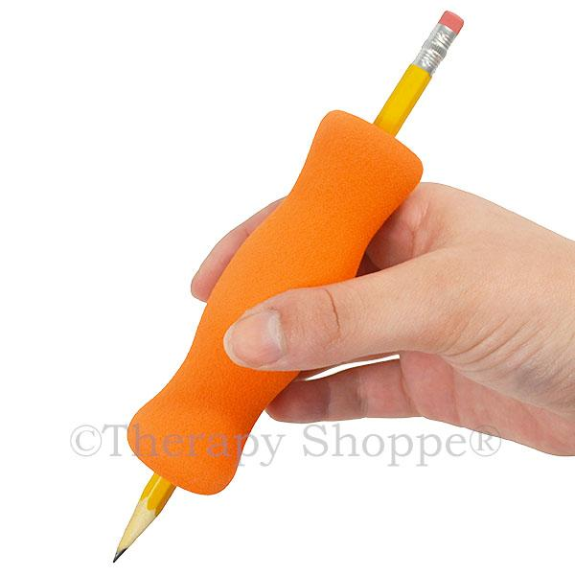

1. Must have soft wrist support that allows regular movement
2. Number of units to be made: 20
3. Cost of production should be under $300 in raw materials, but not including labor costs. Cost of equipment to make is also not considered.
4. Should have a top view area of between 300mm by 300mm to 900 mm by 600mm.
5. Should be less than 2 kg in mass.
6. Should have 8 directional functions via 1 stick and 4 to 6 digital buttons/switches.
7. The button/switches should be comfortable for an average human hand to reach.
8. Uses standard USB Type A or USB Type C at 5v 0.5 A for both power and data.
9. Add a single button switch to swap between left handed mode and right handed mode
10. Should be simple enough to construct for an untrained middle schooler to construct with guided instruction.

**Design Concepts:**

Design 1: **Reversible Basic Foam Stick, Box Base**

<https://www.tinkercad.com/things/eb4LIGbfcsD-grand-duup-habbi/edit?sharecode=xh11hiPam7w63swecRyOHn8NGJX71ub_cQ3Lp0lAtDQ>

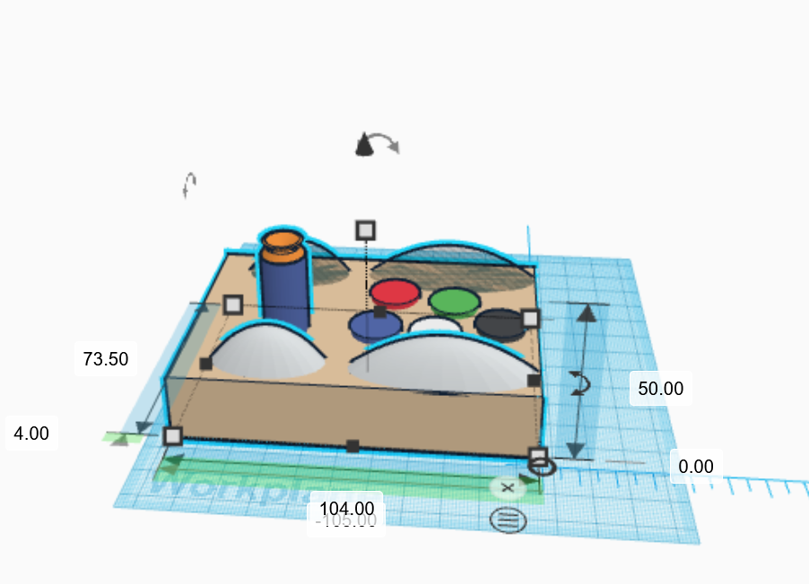

The first possible design is the simplest. The design intent is to build a simple box to house the buttons and sticks and then include soft rubber support for wrists on the button and joystick. Heavy inspiration is taken from arcade sticks currently on the market.

Design 2: **Foam, gripped flightstick with buttons fit to the grip**

It will be based on a flight stick design published by NASA, but modeled with fighting games in mind.

<https://www.tinkercad.com/things/izJ1wF07BsM-second-ergonomic-controller/edit?sharecode=Vrl1XKxfp4cwMCy5ebKarIlfZgdKjd-DAm0cufADVig>

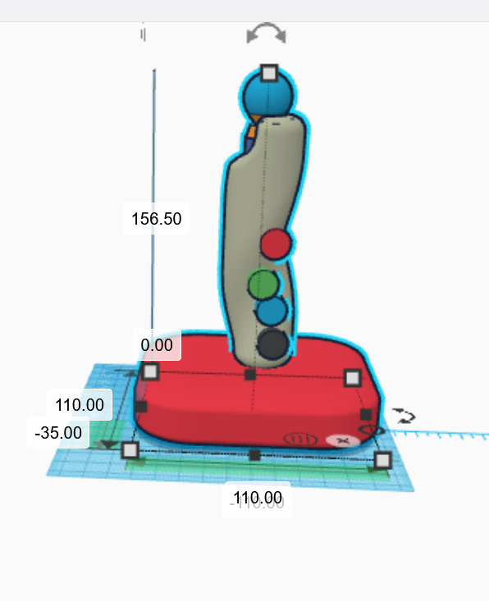

‘Steal’ (borrow with attribution) multiple degrees of freedom from this NASA paper, map many to the same movements to different axes? See the included paper:

<https://www.nasa.gov/centers/dryden/pdf/88752main_H-2512.pdf>

Make/’borrow’ a rubber grip, print it out of TPU on a 3d printer, recommended internal diameter is 33mm: (Download, read and verify)

<https://www.jhandtherapy.org/article/S0894-1130(03)00160-1/pdf>

**Use this pencil grip as the basis for the joystick design: [ Partial Winner]**

[**https://www.thingiverse.com/thing:4281838**](https://www.thingiverse.com/thing:4281838)

Design 3: **Glove Keyboard**

<https://www.tinkercad.com/things/kIWwL8lLioz-shiny-kup/edit?sharecode=iAb09XFRCDQvs0qOQaA5iJj4djsV5_ObFd8lst9d-M8>

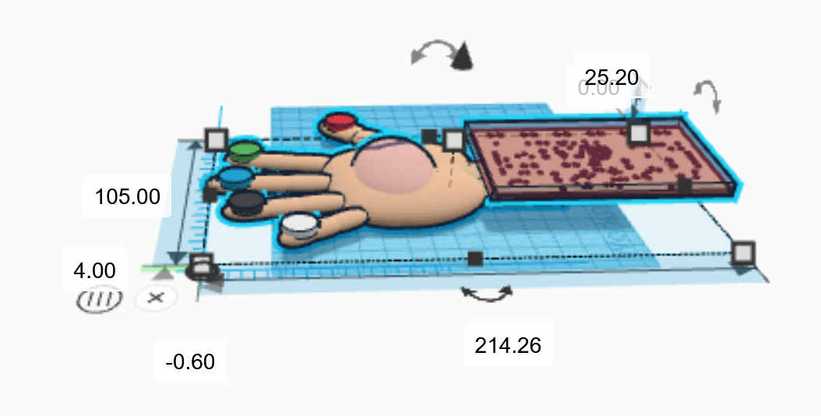

Pink rubber on the backhand houses a wired and omnidirectional RFID sensor.

Each colored button on the fingertips houses a unique, non-powered RFID chip. The pink sensor detects change in signal strength to the RFID chips as unique button presses, and relays this back to the Makey Makey via thin (not shown) data cable. The Makey Makey is housed like a ‘Pip-boy’ on the person’s wrist in a plastic casing.

It's an expensive idea, but would be the ultimate in ergonomics. This could be especially useful if gestures and other more natural hand movements could be mapped to actions in video games.

I will present this as a possible idea, but I am NOT the author of this design for a glove keyboard:

<https://grabcad.com/library/rahab-hand-1>

It also requires software and GPU hardware to work, see:

<https://www.youtube.com/watch?v=6raRftH9yxM>

Value Weights: What is important for choosing from one of the three above options?

| Goal | **Cost** | **DFM (Manufacturability)** | **Ergonomics** | **Response Time** | **Durability** |  | **Score** | **% Importance** |
| --- | --- | --- | --- | --- | --- | --- | --- | --- |
| **Cost** |  | 0 | 1 | 0 | 0 |  | 1 | 10.00% |
| **DFM (Manufacturability)** | 1 |  | 0 | 0 | 1 |  | 2 | 20.00% |
| **Ergonomics** | 0 | 1 |  | 1 | 1 |  | 3 | 30.00% |
| **Response Time** | 1 | 1 | 0 |  | 1 |  | 3 | 30.00% |
| **Durability** | 1 | 0 | 0 | 0 |  |  | 1 | 10.00% |
|  |  |  |  |  |  |  |  |  |
|  |  |  |  |  |  |  |  |  |
|  |  |  |  |  |  |  |  |  |
| % Importance | 10.00% | 20.00% | 30.00% | 30.00% | 10.00% |  |  |  |

Ergonomics and response time were the dominant values, followed by DFM (how easy to actually make in real life), then leaving cost and durability tied for last in how I score options.

| Goal |  | **Cost** | **DFM (Manufacturability)** | **Ergonomics** | **Response Time** | **Durability** |  | **Score** |
| --- | --- | --- | --- | --- | --- | --- | --- | --- |
| % Importance |  |  |  |  |  |  |  |  |
| **Reversible Basic Foam Stick, Box Base** | Rating (1 to 10) | 9 | 9 | 7 | 8 | 7 |  |  |
|  | Score | 0.90 | 1.80 | 2.10 | 2.40 | 0.70 |  | **7.90** |
| **Foam, Gripped Flightstick with buttons fit to the grip** |  |  |  |  |  |  |  |  |
|  | Rating (1 to 10) | 6 | 7 | 9 | 8 | 6 |  |  |
|  | Score | 0.60 | 1.40 | 2.70 | 2.40 | 0.60 |  | 7.70 |
| **Glove Keyboard** |  |  |  |  |  |  |  |  |
|  | Rating (1 to 10) | 2 | 3 | 10 | 5 | 3 |  |  |
|  | Score | 0.20 | 0.60 | 3.00 | 1.50 | 0.30 |  | 5.60 |
| Winner: |  |  |  |  |  |  |  |  |
| The most basic design, the RBFSBB edged out over the design 'inspired' by NASA. It also edges out because I already have the materials on hand to make the entire design. |  |  |  |  |  |  |  |  |
|  |  |  |  |  |  |  |  |  |

By a very close margin, the most basic and first design option (RBFSBB) won out. It is simple and requires far more laser cutting than 3d printing, and this edged it out even though it is less ergonomic than the second, fully 3d printed out of silicone option.

**Tolerance Issues Using Tools:**

Tolerance for Glowforge laser cutter is <https://community.glowforge.com/t/cutting-precision-tolerances-and-horizontal-variation/105294/9>

+/- 0.2032 mm for cuts and all position information

Tolerance for 1/8th inch plywood is +/- 1/64th inch, which is 0.3969 mm

Design goals: Have inserts mimicking dado inserts but simply using the wood’s precut thinness, making a small ‘outer’ perimeter as well.

All M3 screw holes to all corners with diameter of 3.3 mm, with all on-plane holes being 6.6 mm from the closest corners, unless noted otherwise. All cuts for holes and inserts are made using the Glowforge laser cutter.

Tolerances for 3d printed parts varies with printing parameters, but I was able to get it down to +/- 0.1 mm with the smallest layer height and slowest print times allowed on my Makerbot Method I have access to. This is, amazingly, better than the specifications published by Makerbot, see:

<https://www.makerbot.com/3d-printers/method/tech-specs/>

`

**Acknowledgement of outside Models Used:**

Models from others online models used in the project to be acknowledged. That is, I used and dimensioned these, but these are NOT my original models:

Author: Jimmi Henry

<https://grabcad.com/library/sanwa-jlf-tp-8yt-1>

To closely match my Zippy Joystick.

Author: Reiner Mrozek

<https://grabcad.com/library/arcade-button-2>

To closely match our arcade buttons

**Layout Drawing:**

I resized and organized the original sketch from Tinkercad to match the true size that will be made in Inventor:

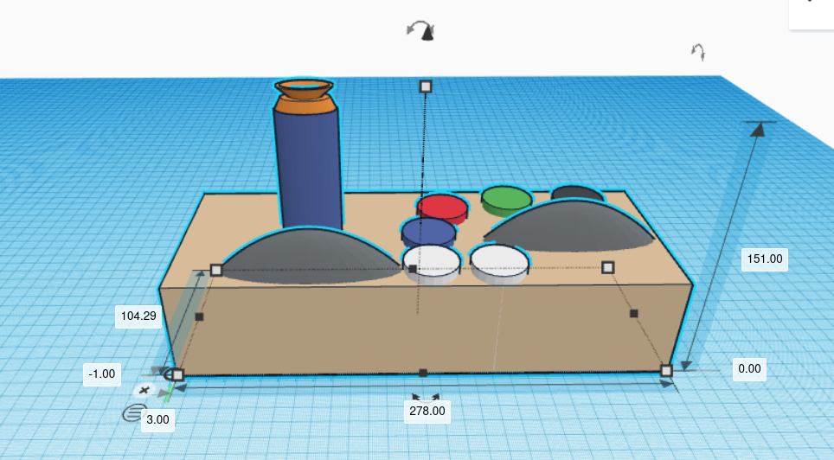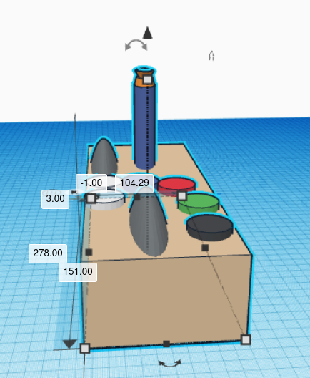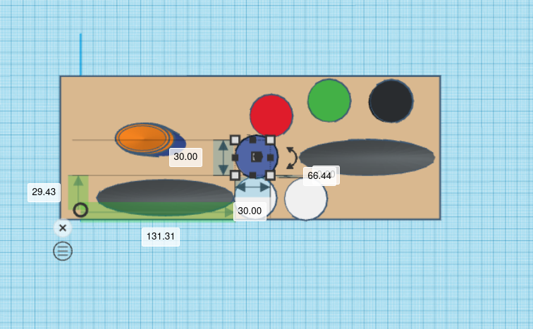

**Costs and Mass:**

| **ITEM** | **QTY** | **PART NUMBER** | **TITLE** | **MATERIAL** | **MASS** | **ESTIMATED COST** |
| --- | --- | --- | --- | --- | --- | --- |
| 1 | 1 | BP-01 | Base Plate | Wood (Cherry) | 0.081 kg | $1.47 |
| 2 | 2 | VP-01 | Vertical Plate | Wood (Cherry) | 0.029 kg | $0.51 |
| 3 | 2 | HP-01 | Horizontal Plate | Wood (Cherry) | 0.053 kg | $0.94 |
| 4 | 8 | C-M3-M | Corner M3 Mount | ABS Plastic | 0.002 kg | $0.05 |
| 5 | 28 | AS 1420 - 1973 - M3 x 6 | M3 Screw (Short) | Steel, Mild | 0.001 kg | $0.10 |
| 6 | 1 | TP-01 | Top Plate | Polycarbonate, Clear | 0.133 kg | $3.33 |
| 7 | 6 | Pushbutton - BG | Arcade Buttons |  | 0.024 kg | $2.48 |
| 8 | 1 | Zippy JLF-TP-8YT | Zippy Joystick (Short Actuator) |  | 0.142 kg | $18.28 |
| 9 | 1 | MM-v12 | Makey Makey V1.2 | Phenolic Resin | 0.048 kg | $49.95 |
| 10 | 3 | AS 1420 - 1973 - M3 x 10 | M3 Screw (Long) | Steel, Mild | 0.001 kg | $0.10 |
| 11 | 7 | BS 4183 - M3 | M3 Nut | Steel, Mild | 0.000 kg | $0.07 |
| 12 | 1 | FSG01 | Ergonomic Pencil Grip | Rubber | 0.029 kg | $0.81 |
| 13 | 2 | SW-S01 | Silicone Wrist Support | Rubber, Silicone | 0.082 kg | $7.99 |
| 14 | 4 | ISO 7093 - 3 - 140 HV | Oversized M3 Washer | Stainless Steel | 0.000 kg | $0.07 |
|  |  |  |  |  |  |  |
|  |  |  |  |  |  |  |
|  |  |  |  |  |  |  |
|  |  |  |  | TOTAL | 0.952 kg | $111.87 |

**Final Assembly Drawing, Followed by Final Production Detail Drawings:**